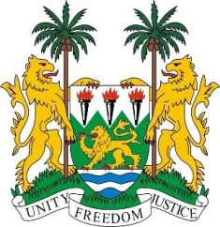
SIERRA LEONE
22nd Session of the UPR

PANAMA

Statement by Ambassador Stevens

6 May 2015

Mr President,

Sierra Leone welcomes the high-level delegation of Panama and thanks them for the comprehensive update on their national report.

My delegation notes with appreciation their efforts to significantly reduce unemployment and the provision of the right to universal primary education for all of its citizens.

Sierra Leone especially commends efforts undertaken by the Government of Panama to assist households living in extreme poverty to meet their basic needs through programmes and incentives such as the conditional cash transfer (CCT) and welfare programmes (like the Opportunities Network).

My delegation is however concerned at the significant disparities between the indigenous and non-indigenous communities, in particular as regards political participation and urges Panama to take steps to enforce their rights.

Sierra Leone would also like to encourage Panama to establish a national policy which comprehensively protects and promotes the rights of children, especially with regard to the minimum age of marriage of boys and girls (which currently stands at 16 and 14 respectively).

In addition, the government should be encouraged to develop initiatives to improve access to healthcare and education in rural areas and within indigenous communities. In addition, my delegation believes that enhancing equal access to employment and promoting equal pay for women would better improve their participation and strengthen their social empowerment.

Sierra Leone would like to make the following recommendations:

- Ratify the ICRMW and the ILO Indigenous and Tribal Peoples Convention, 1989 (No. 169).
- Submit its overdue reports to the relevant UN treaty bodies.
- Enforce laws which further ensure the integration and socio-economic participation of Afro-Panamanians and people of African descent.
- Enact anti-discrimination laws which would better protect the rights of indigenous communities.

To conclude, Sierra Leone wishes Panama a successful completion to this second cycle of their review process.

Thank you, Mr President.

